Nixie bargraph Thermometer

|  |  |
| --- | --- |
| Author | Emre Dag |

Content

Introduction 1

Material and methods 2

2.1 Passive components 2

2.2 Tube 2

2.3 Semiconductors 2

2.4 Arduino 3

2.5 Building process 3

Results 4

5.1 Electrical schematic 4

5.1.1 Switching power supply 4

5.1.2 IN-9 tube drive circuit 4

5.1.3 RGB LEDs 5

5.2 PCB design 6

5.2.1 Top layer 6

5.2.2 Bottom layer 6

5.2.3 Polygon pour 7

5.3 Finalized design 7

Discussion 8

Reference list 8

# Introduction

This project is a Nixie bargraph thermometer, which uses a IN-9 Nixie bargraph tube to measure temperatures.

It is a project that uses a unique method to measure temperatures the tube is not used that often, because it is hard to construct properly. [1]

The starting point of the project is the Elektor magazine in which things like components and schematics can be found and are fully described. This application note gives an overview of the materials, the methods and the results of this project.

# Material and methods

The project uses 51 electronic components and 35 mechanical parts. Together these components cost about €65. The most expensive element is the IN-9 Nixie bargraph tube that costs $10,00 whereas the resistors usually do not cost much and many of them can be obtained at school. The components ordered from Würth Elektronik can be obtained free of charge through a collaboration with the school PXL.

|  |  |  |  |
| --- | --- | --- | --- |
| Component | Supplier | Delivery date | Price |
| Passive components | PXL, Würth, Reichelt, Mouser | April | €17 |
| Tube | Tubes store | March | $10 |
| Semiconductors | Reichelt, Mouser, Farnell, Gotron | April | €15 |
| Arduino Nano | Otronic | April | €7 |

## Passive components

“A passive component is an electronic component which can only receive energy, which it can either dissipate, absorb or store it in an electric field or a magnetic field.” [2] Unlike active components, passive components do not supply energy to a circuit. [2]

The device contains 23 resistors, 8 capacitors and only one inductor in which all of these components have a different value.

## Tube

One of the most important and main components is the Nixie bargraph tube itself. This is a Russian IN-9 indicator tube. There is a gas mixture in the tube which creates the lighting effect. It is important that the tube works properly otherwise the whole project will not work. [1]

The tube operates at a DC voltage of 150 V. It also needs a current source made with an operational amplifier (opamp) and transistors. [1]

There are other versions of the tube like the IN-13 tube which is longer and needs less current, however the light output of the IN-9 is higher and the wires are longer. [1]

## Semiconductors

There are different types of semiconductors used in the device: 3 normal diodes, 2 RGB LEDs, 6 transistors and 3 ICs are used for the project.

The normal diodes are used to let the current flow in only 1 direction, while the RGB LEDs provide a light show.

The ICM7555 IC and two transistors are used in the switching power supply part of the circuit. The switching power supply ensures that the output voltage is amplified from 5V to 75V. Further, the voltage doubler circuit ensures that this 75V is converted to 150V. [1] The ICM7555 is a CMOS timer. [3]

There are also two other ICs in this project, namely the LM6142NOPB and DS18B20+. The LM6142NOPB is an IC consisting of 2 Opamps, while the DS18B20+ is a digital thermometer used for the measurements. [4]

## Arduino

Another very important part of the project is the Arduino Nano microcontroller which ensures the correct operation as desired. As stated on the Arduino website: "Arduino is an open-source electronics platform based on easy-to-use hardware and software." [5]

The software is driven by the Arduino Nano which sends data and PWM signals to the circuit. [1] It also provides the circuit a voltage supply of 3,3V and 5V that it gets from the USB connection with the PC [1]

There are also other models of the Arduino. The reason why an Arduino Nano is used, instead of the other models, is because it is cheaper. [1]

## Building process

This flowchart shows the construction process of the project. Both the schematic and the PCB designs are drawn in Altium Designer. Simultaneously, it is important to order the components in time. When everything arrives, the soldering of the components starts. Further, it is important to test the project and correct all the mistakes encountered. In the meantime, the case is drawn in AutoCAD 2021.

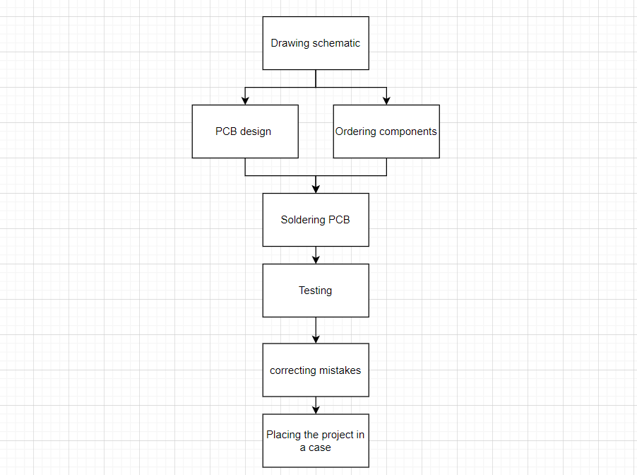

Figure 1 : flowchart process

# 

# Results

## Electrical schematic

The Schematic is fully drawn in Altium designer.

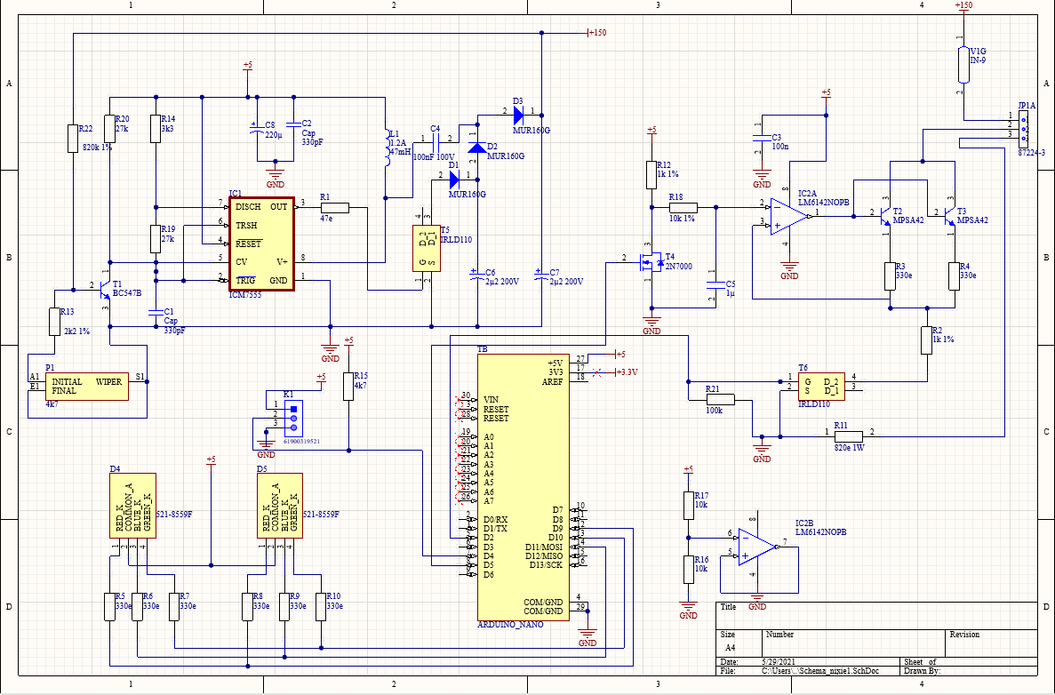

Figure 2 : Electrical schematic

### Switching power supply

The circuit at the top left of figure 2 and around the ICM7555 is the switching power supply. This part increases an input voltage of 5V to an output voltage of 150V. [1]

This circuit can be divided into two parts. The first part increases the 5V input voltage to 75V. [1] The second part is a voltage doubler, which doubles the generated 75V to 150V. The advantage of these two steps is that most components should only be able to handle 75 V. [1] The voltage doubler is a DC to DC boost converter. The IRLD110 is switched on and off by the ICM7555 IC, which is a CMOS timer. The pulse width of the output of the IC is determined by the external components. [3]

A boost converter works like this. The output capacitor charges when the IRLD110 MOSFET is switched off. The inductor charges and stores energy by generating a magnetic field when the MOSFET closes. When the MOSFET opens again, the stored energy is released along with the power supply. A continuous process of switching ensures that the output is consistently higher than the input. [6]

### IN-9 tube drive circuit

A current source drives the IN-9 tube, which is made out of the LM6142NOPB Opamp and the two MPSA42 transistors. The Arduino Nano provides the Opamp of an input signal. A voltage of 3.3V is used instead of a voltage of 5V because of the voltage drop over the USB cable. The transistors are used to maintain the temperatures between reasonable limits. [1]

### RGB LEDs

The RGB LEDs cause a light show. The two LEDs are both common anodes which means that the anodes can be connected together to the 5V. The Arduino uploads the data for the red, blue and green LEDs.

## PCB design

The PCB design is also drawn in Altium designer.

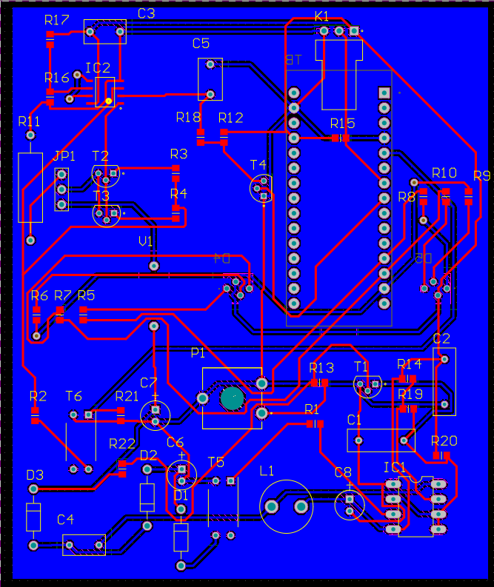

Figure 3 : PCB design

### Top layer

Almost all components are mounted on the top layer. All the SMD components are also on the frontside which makes it easy to screen and put them in the oven.

Almost all resistors are SMD. Only one resistor is through-hold because the SMD version does not exist. All the SMD resistors are size 0805. In addition to the resistors, the LM6142NOPB is also an SMD component due to its availability. The remaining elements are through-hold.

### Bottom layer

The bottom layer consists of three components, namely the two RGB LEDs and the Arduino Nano. The RGB LEDs are on the bottom so that the light can be seen better. The Arduino Nano is mounted to the bottom layer because there is more room.

### Polygon pour

As mentioned on the Altium website: “A polygon pour is a group design object that is made up of simpler primitive objects. Polygon pours are used to create a solid or hatched (lattice) area on a PCB layer, using either Region objects or a combination of Track and Arc objects.” [7]

## Finalized design

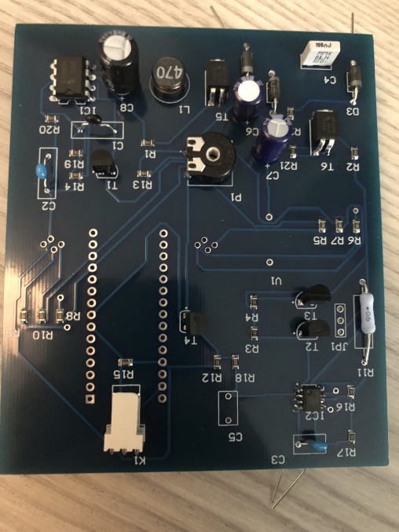The PCB is made by JLCPCB, which is a global PCB manufacturer recommended by the teacher. The design is 100 cm by 83 cm. This means that the PCB only costs €3. The shipping costs, on the other hand, are expensive because it comes from China.

Figure 4 : mechanical PCB design

# Discussion

Most components are unavailable in the standard library in Altium designer. They are downloaded from the internet and imported to the schematic design. The sites used include Snapeda, Farnell and Mouser. The downloadable Altium library loader is also a tool used in this project. Some of the components, however, are not even available on the internet. These elements are manually drawn with the drawing wizard in Altium Designer. The footprint manager is a tool to look at all the footprints. Schematic libraries make it possible to draw and edit symbols. Both the footprint and the symbol of the IN-9 tube are drawn manually.

It is important to test if the Nixie tube works before soldering it to the PCB. The tube is tested by applying a high voltage directly to the tube itself. The tube works if it ignites. The light released depends on how much voltage is connected.

Tweezers help place the SMDs on the solder paste. The places that are not properly fused in the oven are manually corrected with a soldering iron. The LM6142NOPB was repurchased because a through hold model was purchased while an SMD was needed. This IC is soldered completely by hand.

It would have been smarter if the PCB had been ordered earlier because the company's delivery time is longer than expected. Because of the coronavirus, delivery is also taking longer.

The software comes directly from the Elektor magazine website itself and can be uploaded to the microcontroller with a USB cable.

# Reference list

|  |  |
| --- | --- |
| [1] | I. J. a. P. S’heeren, "Nixie Bargraph Thermometer," *Elektor magazine,* p. 8, August 2018. |
| [2] | R. Grigalunas, "escomponents.com," ES components, 31 July 2019. [Online]. Available: https://www.escomponents.com/blog/2019/7/31/active-amp-passive-components-what-is-the-difference-between-the-two. [Accessed 03 April 2021]. |
| [3] | NXP, "ICM7555," NXP Semiconductors, The Netherlands, 2009. |
| [4] | Maxim Integrated, "DS18B20," Maxim Integrated, United States, 2019. |
| [5] | Ardiuno, "Arduino.cc," Arduino, 05 February 2018. [Online]. Available: https://www.arduino.cc/en/Guide/Introduction. [Accessed 4 April 2021]. |
| [6] | Electrical4U, "Electrical4U," Electrical4U, 23 May 2021. [Online]. Available: https://www.electrical4u.com/boost-converter-step-up-chopper/. [Accessed 29 May 2021]. |
| [7] | J. Howie, "Altium," Altium, 1 October 2019. [Online]. Available: https://www.altium.com/documentation/altium-designer/pcb-obj-polygonpourpolygon-pour-ad?version=18.1. [Accessed 30 May 2021]. |